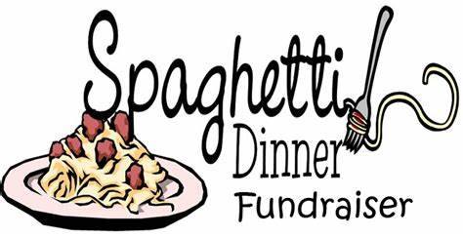
Take the night off from cooking and come out to support our youth!!
Meal will include spaghetti, rolls, salad, drink & dessert.
Saturday, April 29, 2023 // 5:00-8:00 pm
Cost: 5 years old & under – Free
6 to 12 years old – $6.00 per person
13 years old & over – $12.00 per person

Please make a reservation by filling out this form and giving to one of the youth, Jackie Bear or Heather Nelson.

Name:
Number per age: 5 & under 6 to 12
13 & over
Don’t forget to invite friends and family!!
Reservations are not required, but greatly appreciated. Payment will be collected at the door; cash, check & payment via Continue to Give (QR Code will be available) will be accepted.

